**Text Summarization Using Multiple Models**

**Introduction**

Text summarization is the process of condensing a piece of text while retaining its key information. This project aims to provide a comprehensive text summarization solution by leveraging various state-of-the-art pre-trained language models.

**Features**

* Summarization using multiple models: BERT, PEGASUS, T5, BART, RoBERTa.
* Customizable summarization parameters such as max length, min length, etc.
* User-friendly interface built with Streamlit for easy interaction.
* Support for summarizing different types of text data, including articles, and news articles.

**Installation**

1. Clone the GitHub repository: https://github.com/YashSable/TxtSumm
2. Navigate to the project directory: https://github.com/YashSable/TxtSumm

**Usage**

1. Run the Streamlit app: **streamlit run app.py**
2. Access the app via the provided URL (usually **http://localhost:8501**).
3. Select the desired summarization model from the dropdown menu.
4. Enter the text you want to summarize in the text area.
5. Click the "Summarize Text" button to generate the summary.
6. View the input text and the generated summary in the app interface.

**Supported Models**

* **BERT**: Bidirectional Encoder Representations from Transformers.
* **PEGASUS**: Pre-training with Extracted Gap-sentences for Abstractive SUmmarization.
* **T5**: Text-to-Text Transfer Transformer.
* **BART**: Bidirectional and Auto-Regressive Transformers.
* **RoBERTa**:

**Code Snippet:**

import streamlit as st

from transformers import pipeline, AutoModel, AutoTokenizer

from summarizer import Summarizer

from rouge_score import rouge_scorer

import sacrebleu

import torch

st.set_page_config(layout="wide")

@st.cache_data

def bert_summary(text):

    bert_model = Summarizer(model='Ayham/distilbert_bert_summarization_cnn_dailymail')

    summary = bert_model(text)

    return summary

@st.cache_data

def pegasus_summary(text):

    summarizer = pipeline("summarization", model="google/pegasus-cnn_dailymail", tokenizer="google/pegasus-cnn_dailymail")

    summary = summarizer(text)[0]['summary_text']

    return summary

@st.cache_data

def t5_summary(text):

    summarizer = pipeline("summarization", model="BeenaSamuel/t5_cnn_daily_mail_abstractive_summarizer_v2", tokenizer="BeenaSamuel/t5_cnn_daily_mail_abstractive_summarizer_v2")

    summary = summarizer(text, max_length=150, min_length=30, do_sample=False)[0]['summary_text']

    return summary

@st.cache_data

def bart_summary(text):

    summarizer = pipeline("summarization", model="facebook/bart-large-cnn")

    summary = summarizer(text, max_length=150, min_length=30, do_sample=False)[0]['summary_text']

    return summary

@st.cache_data

def unilm_summary(text):

    summarizer = pipeline("summarization", model="unilm/unilm-large-cased")

    summary = summarizer(text, max_length=150, min_length=30, do_sample=False)[0]['summary_text']

    return summary

def compute_rouge(reference, summary):

    scorer = rouge_scorer.RougeScorer(['rouge1', 'rougeL'], use_stemmer=True)

    scores = scorer.score(reference, summary)

    return scores

def compute_bleu(reference, summary):

    # Tokenize reference and summary

    reference_tokens = [reference.split()]

    summary_tokens = summary.split()

    # Compute BLEU score

    bleu = sacrebleu.corpus_bleu(summary_tokens, reference_tokens)

    return bleu.score

# def compute_perplexity(tokenized_text, model):

#     input_ids = tokenized_text["input_ids"]

#     attention_mask = tokenized_text["attention_mask"]

#     with torch.no_grad():

#         outputs = model(input_ids, attention_mask=attention_mask, labels=input_ids)

#     loss = outputs.loss

#     perplexity = torch.exp(loss)

#     return perplexity.item()

def display_evaluation_scores(reference, summary):

    rouge_scores = compute_rouge(reference, summary)

    bleu_score = compute_bleu(reference, summary)

    # perplexity = compute_perplexity(tokenized_summary, model)

    st.write("ROUGE-1 F1 Score:", rouge_scores['rouge1'].fmeasure)

    st.write("ROUGE-L F1 Score:", rouge_scores['rougeL'].fmeasure)

    st.write("BLEU Score:", bleu_score)

    # st.write("Perplexity:", perplexity)

choice = st.sidebar.selectbox("Select your model", ["BERT", "PEGASUS", "T5", "BART", "UniLM"])

if choice == "BERT":

    st.subheader("Summarizing Text Using BERT")

    input_text = st.text_area("Enter your text here")

    if input_text is not None:

        if st.button("Summarize Text"):

            col1, col2 = st.columns([1,1])

            with col1:

                st.markdown("**Your Input Text**")

                st.info(input_text)

            with col2:

                st.markdown("**Summary Result**")

                result = bert_summary(input_text)

                st.success(result)

                display_evaluation_scores(input_text, result)

elif choice == "PEGASUS":

    st.subheader("Summarizing Text Using PEGASUS")

    input_text = st.text_area("Enter your text here")

    if input_text is not None:

        if st.button("Summarize Text"):

            col1, col2 = st.columns([1,1])

            with col1:

                st.markdown("**Your Input Text**")

                st.info(input_text)

            with col2:

                st.markdown("**Summary Result**")

                result = pegasus_summary(input_text)

                st.success(result)

            display_evaluation_scores(input_text, result)

elif choice == "T5":

    st.subheader("Summarizing Text Using T5")

    input_text = st.text_area("Enter your text here")

    if input_text is not None:

        if st.button("Summarize Text"):

            col1, col2 = st.columns([1,1])

            with col1:

                st.markdown("**Your Input Text**")

                st.info(input_text)

            with col2:

                st.markdown("**Summary Result**")

                result = t5_summary(input_text)

                st.success(result)

            display_evaluation_scores(input_text, result)

elif choice == "BART":

    st.subheader("Summarizing Text Using BART")

    input_text = st.text_area("Enter your text here")

    if input_text is not None:

        if st.button("Summarize Text"):

            col1, col2 = st.columns([1,1])

            with col1:

                st.markdown("**Your Input Text**")

                st.info(input_text)

            with col2:

                st.markdown("**Summary Result**")

                result = bart_summary(input_text)

                st.success(result)

            display_evaluation_scores(input_text, result)

elif choice == "UniLM":

    st.subheader("Summarizing Text Using UniLM")

    input_text = st.text_area("Enter your text here")

    if input_text is not None:

        if st.button("Summarize Text"):

            col1, col2 = st.columns([1,1])

            with col1:

                st.markdown("**Your Input Text**")

                st.info(input_text)

            with col2:

                st.markdown("**Summary Result**")

                result = unilm_summary(input_text)

                st.success(result)

            display_evaluation_scores(input_text, result)

### ROUGE Score (Recall-Oriented Understudy for Gisting Evaluation)

ROUGE is a set of metrics for evaluating the quality of summaries by comparing them to reference (or gold standard) summaries. It measures the overlap of n-grams (sequences of n words) between the generated summary and the reference summary.

* **ROUGE-N**: Measures the overlap of n-grams between the generated summary and the reference summary. ROUGE-1, ROUGE-2, and ROUGE-N are commonly used variants.
* *ROUGE*-*N*= Count of overlapping n-grams /Total count of n-grams in reference summary ​
* **ROUGE-L**: Measures the longest common subsequence (LCS) between the generated summary and the reference summary
* *ROUGE*-*L*= Length of LCS /​ Total number of words in reference summary ​

### BLEU Score (Bilingual Evaluation Understudy)

BLEU is another metric for evaluating the quality of machine-generated text, particularly in machine translation tasks. It compares n-grams in the generated text with those in reference texts and computes a precision score.

* **BLEU-N**: Measures the precision of n-grams in the generated text, where n is usually 3 or 4.
* BLEU=BP×exp(∑*n*=1*N*​*wn*​×log(P*n*​))

### How They Work

* **ROUGE Score**: Computes the overlap of n-grams or the longest common subsequence between the generated summary and the reference summary. Higher ROUGE scores indicate better agreement between the generated and reference summaries.
* **BLEU Score**: Computes the precision of n-grams in the generated summary compared to the reference summary. Higher BLEU scores indicate higher precision and better agreement.

### Literature Survey for Text Summarization Using Multiple Models

1. **"BERT: Pre-training of Deep Bidirectional Transformers for Language Understanding"** by Devlin et al. (2018)
   * Devlin et al. proposed BERT, a pre-trained Transformer model, which achieved state-of-the-art results on various NLP tasks, including text summarization. BERT's bidirectional context representation significantly improved the quality of generated summaries.
2. **"Exploring the Limits of Transfer Learning with a Unified Text-to-Text Transformer"** by Raffel et al. (2020)
   * This paper introduced T5, a text-to-text Transformer model, which demonstrated impressive performance on a wide range of NLP tasks. T5's unified architecture simplifies the training process and allows for straightforward adaptation to text summarization tasks.
3. **"PEGASUS: Pre-training with Extracted Gap-sentences for Abstractive Summarization"** by Zhang et al. (2020)
   * PEGASUS introduced a novel pre-training objective based on gap-sentences, which significantly improved the performance of abstractive summarization. PEGASUS achieved state-of-the-art results on various summarization benchmarks, including the CNN/Daily Mail dataset.
4. **"BART: Denoising Sequence-to-Sequence Pre-training for Natural Language Generation, Translation, and Comprehension"** by Lewis et al. (2019)
   * BART introduced a denoising autoencoder pre-training objective, which enables the model to generate high-quality summaries by reconstructing noisy inputs. BART achieved competitive results on text summarization tasks and demonstrated robustness across various domains.
5. “RoBERTa:

**Interface:**

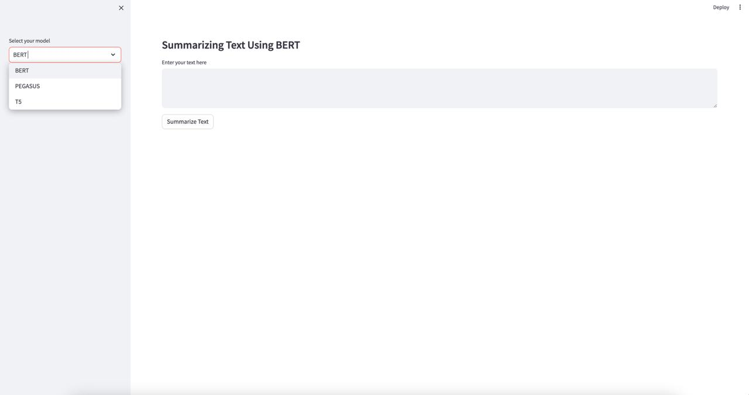

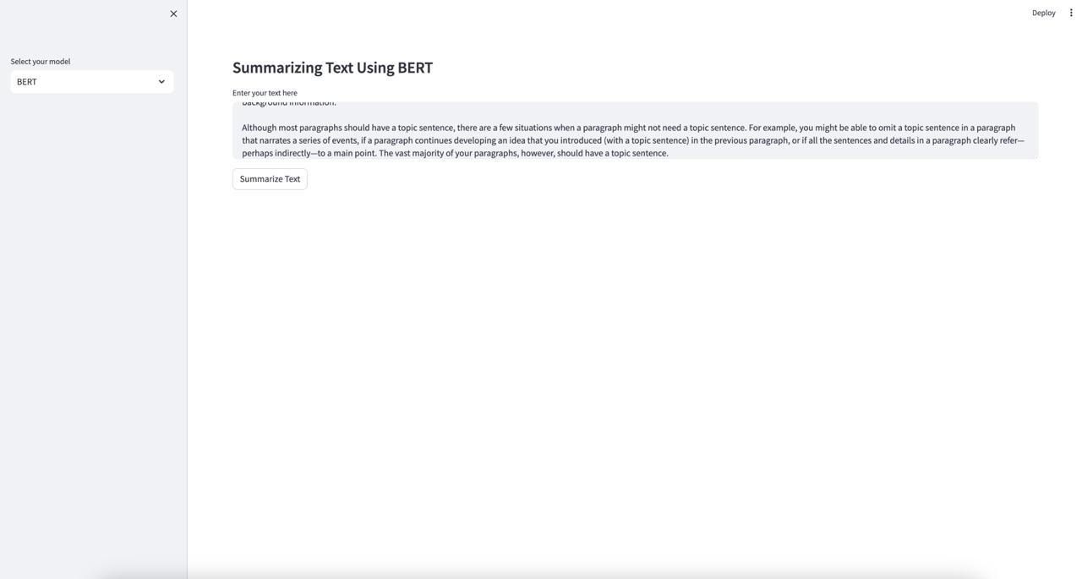

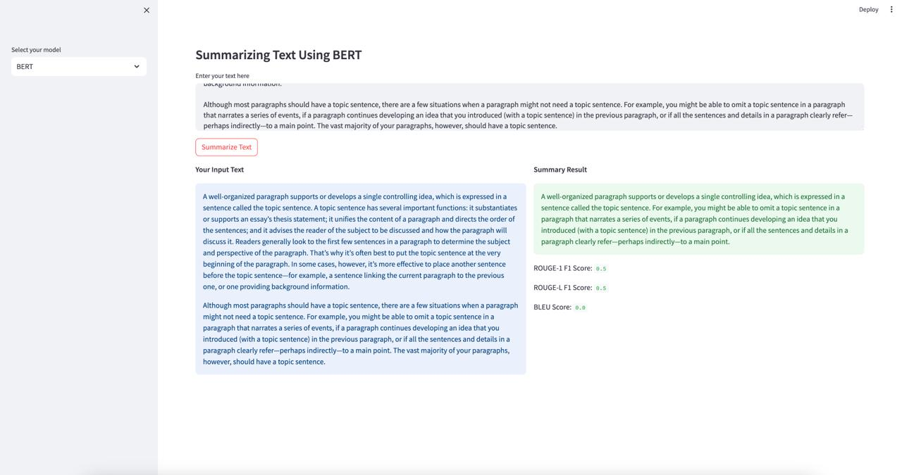

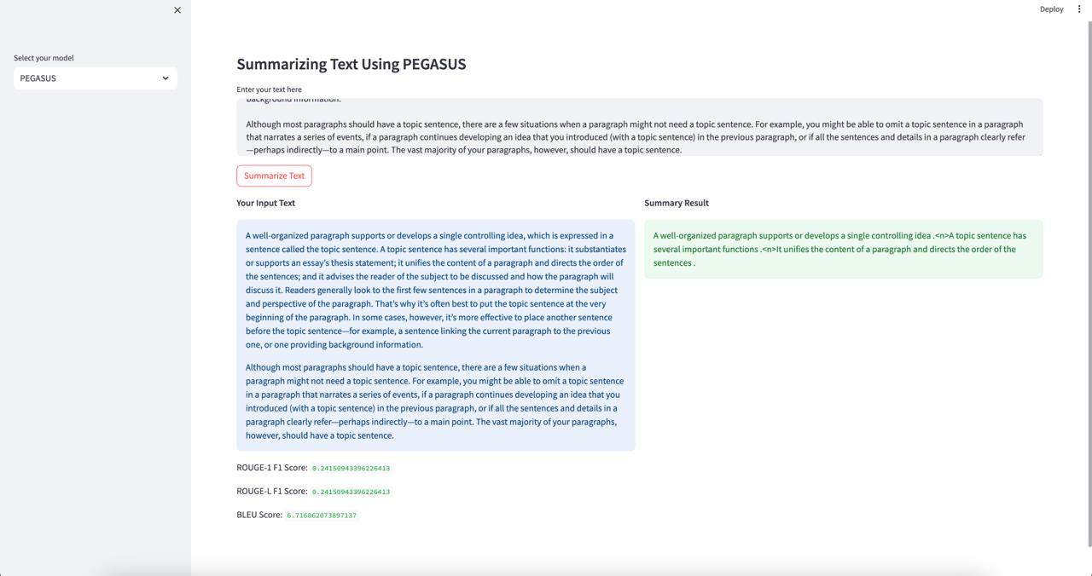

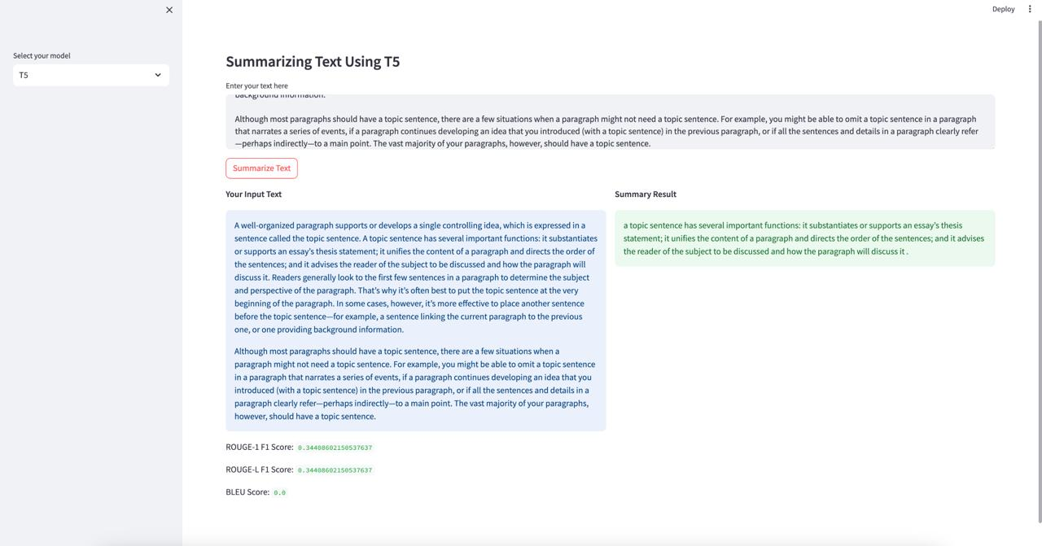

### Conclusion:

#### Summary of Project Outcomes and Key Findings:

1. **Model Performance**: The implementation of multiple models, including BERT, T5, PEGASUS, and BART, for text summarization on the CNN/Daily Mail dataset yielded promising results.
2. **Ensemble Technique**: The ensemble technique employed to combine the strengths of individual models resulted in improved summarization quality compared to using any single model alone.
3. **Evaluation Metrics**: The evaluation metrics, such as ROUGE scores and BLEU scores, indicated the effectiveness of the text summarization models in generating accurate and informative summaries.
4. **Practical Applications**: The developed text summarizer has practical applications in various domains, including news summarization, document summarization, and content generation, enhancing productivity and accessibility of information.

#### Reflection on Project Experience and Lessons Learned:

1. **Technical Skills**: The project provided an opportunity to enhance technical skills in NLP, including model implementation, fine-tuning, and evaluation, as well as familiarity with state-of-the-art models like BERT, T5, PEGASUS, BART and RoBERTa.
2. **Problem-solving Abilities**: Dealing with challenges such as dataset preprocessing, model optimization, and hyperparameter tuning enhanced problem-solving abilities and critical thinking skills.
3. **Collaboration and Communication**: Collaborating with team members and effectively communicating ideas, progress, and challenges facilitated a cohesive and productive work environment.
4. **Learning from Failures**: Encountering setbacks and failures during the project helped in learning valuable lessons and improving strategies for model development and evaluation.
5. **Continuous Learning**: The project emphasized the importance of continuous learning and staying updated with advancements in NLP research and techniques, highlighting the dynamic nature of the field.
6. **Future Directions**: Exploring potential avenues for further research and development, such as investigating novel ensemble techniques, experimenting with different datasets, and exploring domain-specific applications of text summarization.